1) Make sure you are logged in.

2) Go to “Dashboard”: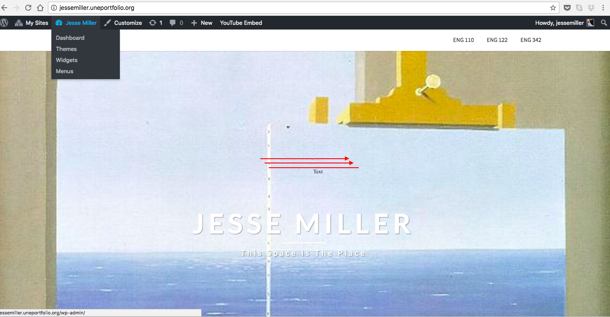

3) Go to the side menu and click on “Appearance” and then when the bar pops up, click “Menus”:
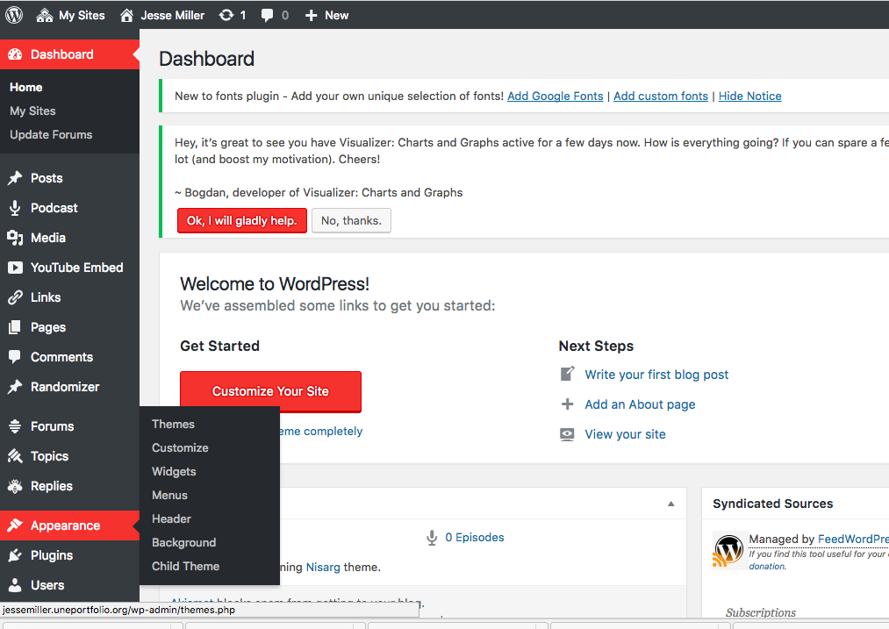

4) Now, click on the pages you’ve created hit “Add to Menu” below. This should move them the pages to the spot that reads “Menu Structure.” Click Top “Menu” and “Save Menu.”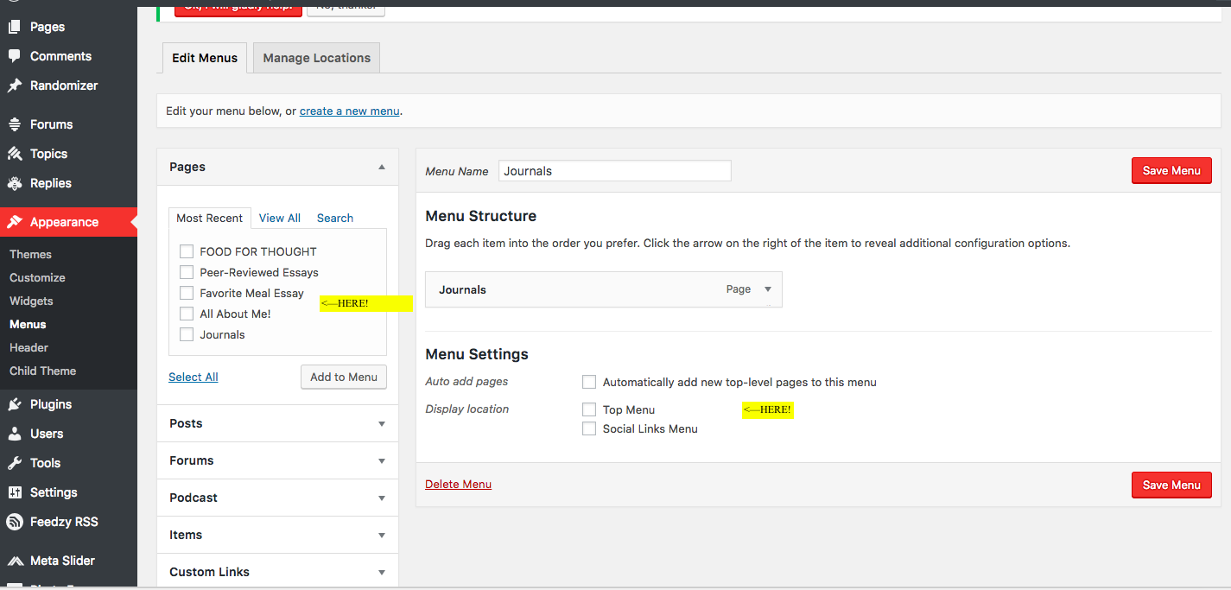

5) Now, when you go up top and move your curser over your name, “Visit Your Page” will scroll down. Click on it, and you should see your pages in a menu at the top of your page:
